From: https://medium.com/@noclador/putins-plan-4652895de8ba
Author: Thomas C. Theiner
Date" Jan 28, 2022; A 14 min read; Listen
Keywords: DNR, LPR, Minsk II agreement,

Putin’s plan
by Thomas C. Theiner
In late November the United States briefed allied intelligence and military leaders about Putin’s plan to invade Ukraine. [It could equally well be termed NATO wargame assuming Russia has to maximally attack Ukraine to stabilize its Western Front. –FNC] On 2 December 2021 I published a map summarizing Putin’s invasion plan on twitter. The map did not garner much attention as at that time neither had Russian troops moved into Belarus, nor had the Northern and Baltic fleets’ amphibious assault ships left port on their way towards Odessa.
Today Ukrainian president Zelensky downplayed the risk of a Russian invasion, ignoring the stark and direct warning by US president Biden from yesterday that Putin is all set to go once the last of Russia’s amphibious assault ships have cleared the Turkish controlled Bosporus. Although Putin has not yet made a final decision on the scope of the invasion, Biden is correct in his assessment that an invasion is imminent.
The scenario below is based on Russia’s maximal invasion plan, which was briefed to allies in late November 2021. The scenario also draws from a European army’s December 2021 war game and the analysis of a Western intelligence agency disseminated to allied militaries and leaked to the press in early January 2022 before Russia’s buildup in Belarus.
Until this week a few pieces were still missing, but Russia is now assembling National Guard units needed for the occupation of cities and towns, is moving S-300V anti-ballistic missile system towards Ukraine, is bringing in Russian Railway troops, deploying medical units, stockpiling ammunition, preparing advanced airfields, positioning heavy siege artillery, organizing the logistics, concentrating elite airborne and tank units at Ukraine’s border. Russia has already deployed the majority of its combat forces to the border with Ukraine, is still moving more units towards the front, has sent at least 20,000 troops to Belarus, and Russian special forces operate already inside Ukraine. By the end of next week [circa Friday, Feb 4, 2022] Putin will be ready.

Putin’s motives
"Putin and his lackeys" have made it clear that the very existence of Ukraine as a sovereign nation is unacceptable to them; that the existence of a democratic Ukrainian nation, the very existence of a Ukrainian people is unbearable to them. They repeatedly stated that Ukrainians do not exist, that people, who feel Ukrainian, are in their view, nothing but confused Russians or Poles. Putin also never tires to proclaim Kyiv to be a Russian city that belongs to Russia, just as he proclaimed that Crimea belonged to Russia before annexing it. In short:
- Putin doesn’t care about NATO guaranteeing that Ukraine will never join
- Putin doesn’t care about Ukraine "reintegrating" Donbas
- Putin doesn’t care about installing a puppet regime in Kyiv
The negotiations Russia demanded the US engage in were never meant to move beyond the first meeting. Putin wanted the US to walk away from his "insane" demands so his propaganda could then blame the invasion on “America’s rejection of negotiations”. And invade he will. And as Biden announced that both, a minor incursion or a full invasion, will result in the same severe sanctions, there is no reason for Putin to limited his war.
But Putin never wanted a limited war anyway: he wants to invade, occupy, annex and enslave Ukraine, and then russify its people, with all the terror, torture, murder and genocide such a policy entails. He said so, he keeps telling us, and he wrote it down and published it last summer.

Putin’s forces
Russia will invade Ukraine. It is foolish to hope otherwise. Russia has moved every halfway combat-ready unit to the border with Ukraine. This is the largest accumulation of forces since the Warsaw Pact invaded of Czechoslovakia in 1968. In all of its history NATO has never pulled as many troops together as Russia does right now.
Besides troops Russia is also amassing enormous quantities of ammunition in open fields near the border with Ukraine. Even from the Pacific Coast troops and ammunition were shipped across Russia to the border with Ukraine — 9,000 km, akin to moving troops from Rio de Janeiro to Los Angeles. Russia claims that all these units were moved for an exercise. As if those troops couldn’t exercise on their training ranges on the Pacific Coast, as if those exercising troops needed 100,000s of artillery shells for a few days of training.
Trains with Iskander ballistic missiles are on the move towards Ukraine — as if the 300+ missiles stored in Russia’s Southwest aren’t enough for an “exercise”. Russia is massing pontoon bridges, which an army only needs if it intends to cross a mile wide river like the Dnieper. Russia is bringing in fighters, bombers and helicopters from beyond the Urals and even the Pacific Coast, even though the two thirds of Russian Air Force assets are already based in strike distance of Ukraine. Russia is amassing every available amphibious landing ship in the Black Sea, and — like Belarus — Russia is calling up division-level numbers of reservists. This is not an exercise.

Putin’s aims
It’s obvious what will happen, but how will it happen? Russia will invade Ukraine from the North, East, and South. There will be three operational thrusts, each commanded by one of Russia’s three army commands currently deployed near Ukraine:
- Kyiv Operation — 1st Guards Tank Army
- Dnieper Operation — 20th Guards Combined Arms Army
- Odessa Operation — 8th Guards Combined Arms Army
The Kyiv and Odessa Operations are the main thrusts, as control of Kyiv and a corridor from Russia to Transnistria are the primary operational aims. As for Ukrainian defense plans and preparations, known and assumed — none of them will be discussed here. No one wants to aid Putin and it is best if Russian soldiers only discover Ukrainian defense preparation once they find themselves under Ukrainian fire.
Before the invasion Russia will create a false-flag event as pretext: either Putin’s military will attack Russia or the Putin’s intelligence agencies will stage a chemical weapons attack in Donbas. Fittingly Putin’s defense minister Shoigu has already publicly blamed the CIA if the latter happens. Once Putin’s propaganda has videos of “Russian” corpses, then Russia’s military, coincidentally and conveniently already placed in combat readiness on Ukraine’s borders, will invade.
Initially Russia will
shell Ukrainian positions along the border and the Donbas front-line with rockets and artillery; will
- fire ballistic missiles at Ukrainian command and control centers; will
- strike air-defense positions inside Ukraine with long range missiles;
- will cyber-war Ukraine’s IT-infrastructure, communication networks, and electric grid into collapse;
- will crater airport runways with ballistic missiles; will level government buildings in Kyiv with Iskander missiles; will
- decouple Ukraine from the internet.
Then Russia’s air force will strike military positions, bases, depots and formations between Russia and a line running from Korosten to northern Moldova. The aim of this phase is to decapitate and demoralize Ukrainian forces, and prevent reservists from being called up.
Already on the first day of the war Russian forces will cross the border. Ukrainian formations will be hit with massive barrages of missile, rocket, and artillery fire and sustained air attacks. Russia’s armored spearheads will not occupy smaller towns and cities, but advance towards Ukrainian units, then try to pin these units down in the open so Russian artillery and air power can decimate them.
As Russian forces are highly depended on railways for their logistics and every 100 km of railway captured intact will greatly improve Russian logistics and therefore the Russians will occupy cities with key railway junctions. Russia’s army will also force their way into cities, which house Ukrainian military bases and depots to raid and destroy these. This will be done to ensure no remaining equipment or weapons at the bases can be used by Ukrainian volunteers, reservists and partisans to attack Russian rear echelons.
Russia’s armored spearheads will aim for the dams along the Dnieper river, as, unlike bridges, Ukraine can not blow these dams up, as doing so would flood cities and villages further downriver and drown 10,000s. Once Russian forces have reached the outskirts of Ukraine’s largest cities the Russians will encircle and besiege them, as the Putin’s general staff is well aware that urban combat is bloody, unpredictable and makes for unpalatable news reports. Russia plans to encircle and besiege Kyiv, Kharkiv, Odessa, Dnipro, Zaporizhia, Kryvyi Rih, Mykolaiv, and Mariupol. Besiege to famish and freeze the population by cutting electricity and gas, stopping water and food supplies in the middle of the harsh Ukrainian winter. The Russians assume that once civilians will freeze and starve, and children and elderly will die, Ukrainian commanders will be forced to surrender.
If you believe Russia’s military won’t starve and slaughter civilians, then you have not paid attention to Russia’s campaign in Syria, which for six years now has been relentlessly bombing schools, kindergartens, hospitals, and refugee camps.
Russia does not plan to occupy all of Ukraine. Putin’s plan is to occupy and annex Eastern, Southern and Central Ukraine and draw Russia’s new Western border somewhere West of the Korosten-Vinnytsia-Transnistria line. As of now Russia has no intentions to invade Western Ukraine, where resistance would be fiercest. Furthermore an emasculated, impoverished rump-statelet centered around Lviv will be no threat to Putin’s new empire and useful as a buffer to NATO countries. Once Putin’s forces reach Transnistria he will also annex that region.

Putin’s invasion
The operational details of Putin’s offensive as briefed in November and war-gamed in December:
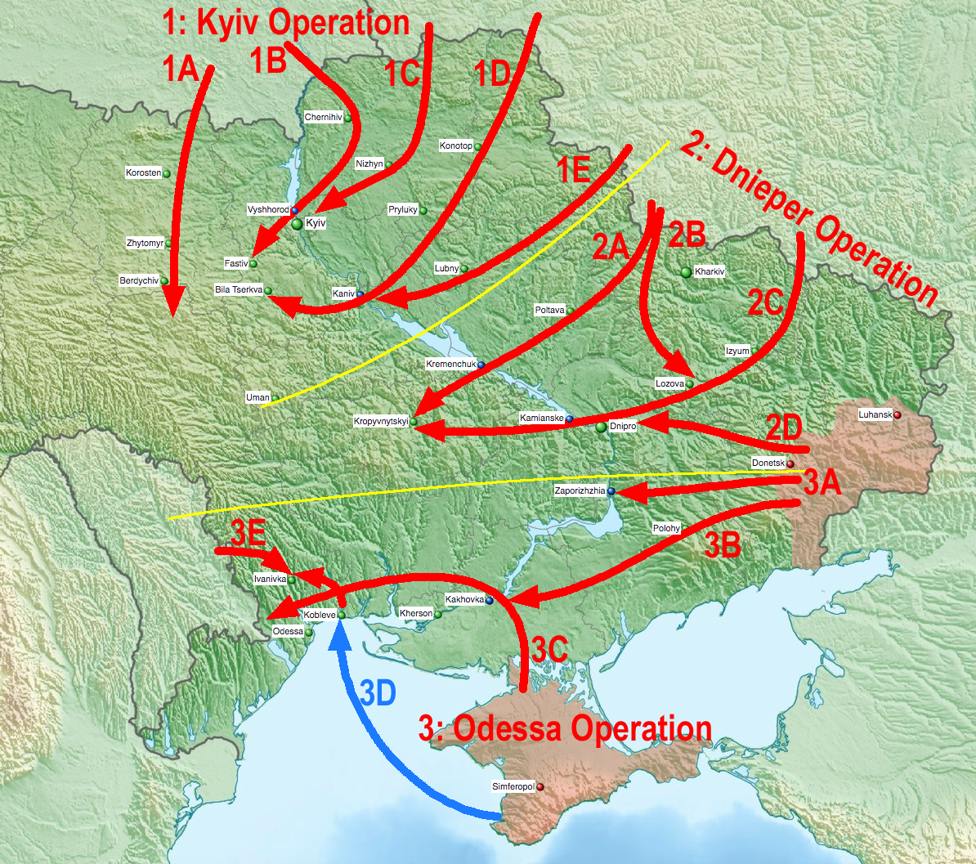
- Kyiv Operation
Operational aim: isolate, encircle, and besiege Kyiv
- 1A — cut Kyiv off from western Ukraine
• advance from Mazur, Belarus
• take the rail and road junction at Korosten
• take the rail and road junction at Zhytomyr
• raid and destroy the 95th Air Assault Brigade’s base in Zhytomyr
• raid and destroy the Su-27 fighter base in Ozerne to the South of Zhytomyr
• advance to Berdychiv
• raid and destroy the 26th Artillery Brigade’s base in Berdychiv
• take the rail and road junction at Kozyatyn
• take and repair the Mazur-Korosten-Zhytomyr-Fastiv railway
• secure the Russian siege ring of Kyiv from the West — destroy Ukrainian reinforcements arriving from western Ukraine
- 1B — besiege Kyiv from the West
• advance from Gomel, Belarus
• advance to Chernihiv
• raid and destroy the 61st Light Brigade’s base in Chernihiv
• raid and destroy the 1st Tank Brigade’s base in Honcharivske to the South of Chernihiv
• raid and destroy the 169th Training Center in Desna
• cross the Dnieper at the Vyshhorod river dam, which Ukraine can not destroy as blowing it up would flood the lower lying areas of Kyiv
• advance to Fastiv and encircle Kyiv from the West
• raid and destroy the headquarters of Air Command Central and the MiG-29 fighter base in Vasylkiv to the East of Fastiv
• besiege Kyiv from the West
- 1C — besiege Kyiv from the East
• advance from Klintsy, Russia
• take the rail and road junction at Bakhmach
• take the rail and road junction at Nizhyn
• take Nizhyn Airfield and (possibly) use as a forward operating base
• secure the Bakhmach-Nizhyn-Kyiv railway
• advance to Kyiv
• besiege the Kyiv from the East
- 1D — cut Kyiv off from southern Ukraine
• advance from Bryansk, Russia
• take the rail and road junction at Konotop
• raid and destroy the 58th Motorized Brigade’s base in Konotop
• secure the Bryansk-Konotop-Bakhmach railway
• take the road junction at Pryluky
• cross the Dnieper at the Kaniv river dam
• advance to Bila Tserkva and cut Kyiv off from the South
• raid and destroy the 72nd Mechanized Brigade’s base in Bila Tserkva
• raid and destroy the 1129th Anti-aircraft Missile Artillery Regiment’s base in Bila Tserkva
• secure the Russian siege ring of Kyiv from the South — destroy Ukrainian reinforcements arriving from southern Ukraine
- 1E — secure the Kyiv Operation’s left flank (optional)
• advance from Kursk, Russia
• advance to Sumy
• raid and destroy the 27th Rocket Artillery Brigade’s base in Sumy
• advance to Lubny/ Myrhorod
• raid and destroy the Su-27 fighter base in Myrhorod
• take the rail junction at Romodan
• advance to the Dnieper
• raid and destroy the 156th Anti-aircraft Missile Regiment’s base in Zolotonosha
• secure the Bakhmach-Romodan railway
• secure the Russian siege ring of Kyiv from the South-East — destroy Ukrainian reinforcements arriving from south-eastern Ukraine
2. Dnieper Operation
Operational aim: besiege Kharkiv and Dnipro, occupy central Ukraine
- 2A — occupy central Ukraine
• advance from Belgorod, Russia
• take the key rail and road junction at Poltava
• raid and destroy the 46th Air Assault Brigade‘s base in Poltava
• raid and destroy the 18th Army Aviation Brigade’s base in Poltava
• cross the Dnieper at the Kremenchuk river dam
• raid and destroy the 107th Rocket Artillery Regiment’s base in Kremenchuk
• advance to Kropyvnytskyi
• raid and destroy the 57th Motorized Brigade‘s base in Kropyvnytskyi
• secure the Odnorobivka-Poltava- Romodan-Kremenchuk river dam-Koristіvka railway
• destroy Ukrainian reinforcements arriving from western Ukraine
• if opportune advance to Uman
- 2B — cut off Kharkiv, pin down Ukrainian forces in Donbas
• advance from Belgorod, Russia
• raid and destroy the 92nd Mechanized Brigade‘s base in Chuhuiv
• raid and destroy the 203rd Training Aviation Brigade’s base in Chuhuiv
• cut off Kharkiv from the West
• take the rail and road junction at Lozova
• secure the Odnorobivka-Lozova railway
• engage and destroy Ukrainian units from the brigades based at Sievierodonetsk (53rd Mechanized), Bakhmut (54th Mechanized) and Druzhkivka (81st Airmobile) and engaged at the Luhansk front, which might try to disengage from the front and attempt to relieve Kharkiv
• follow-up forces besiege Kharkiv
- 2C — cross the Dnieper and besiege Kryvyi Rih
• advance from Valuyki, Russia
• take the road junction at Izyum
• take the rail junction at Sviatohirsk
• secure the Valuyki-Sviatohirsk railway
• advance to Dnipro city
• raid and destroy the bases of the 25th Airborne Brigade, 93rd Mechanized Brigade, and 1039th Anti-aircraft Missile Artillery Regiment in Hvardiiske and Cherkaske to the East of Dnipro
• attack and degrade the 138th Anti-aircraft Missile Brigade‘s base in Dnipro
• cross the Dnieper at the Kamianske river dam
• advance to Kryvyi Rih
• attack and degrade the 17th Tank Brigade‘s base in Kryvyi Rih
• encircle and besiege Kryvyi Rih
- 2D — besiege Dnipro (DNR forces)
• advance from Donetsk, Ukraine
• break through the Ukrainian front line
• advance to, encircle and besiege Dnipro
3. Odessa Operation
Operational aim: besiege Odessa, link up with Russian forces in Transnistria
- 3A — besiege Zaporizhia (DNR forces)
• advance from Donetsk, Ukraine
• break through the Ukrainian front line
• advance to Zaporizhia, Ukraine’s main logistics hub for the Donbas front
• attack and degrade the 55th Artillery Brigade‘s base in Zaporizhia
• encircle and besiege Zaporizhia from the East
• secure a bridgehead over the Dnieper at Rozumivka South of Zaporizhia
• build a pontoon bridge over the Dnieper at Rozumivka, as corssing the Zaporizhia river dam would require to fight through Zaporizhia
• encircle and besiege Zaporizhia from the West
• raid and destroy the 301st Anti-aircraft Missile Regiment ‘s base in Nikopol
- 3B — land bridge to Crimea
• advance from Taganrog, Russia
• break through the Ukrainian front line
• detached DNR and reservist forces to encircle and besiege Mariupol
• attack and degrade the 56th Motorized Brigade‘s base in Mariupol
• take the rail junction at Fedorіvka
• take the road junction at Melitopol
• advance to Nova Kakhovka
• link up with Russian forces advancing from Crimea
• cross the Dnieper at the Kakhovka river dam
• advance to Kherson
• raid and destroy the 11th Army Aviation Brigade’s base in Kherson
• raid and destroy the 208th Anti-aircraft Missile Brigade’s base in Kherson
• secure the Crimea-Fedorіvka-Nova Kakhovka dam-Snihurivka railway
- 3C — occupy the coast and reach Transnistria
• advance from Crimea, Ukraine
• break through the Ukrainian front line
• advance to Nova Kakhovka
• raid and destroy the 57th Motorized Brigade‘s base in Nova Kakhovka
• link up with Russian forces advancing from Donbas
• cross the Dnieper at the Kakhovka river dam
• advance to Mykolaiv
• attack and degrade the 36th Naval Infantry Brigade‘s base in Mykolaiv
• attack and degrade the 79th Air Assault Brigade‘s base in Mykolaiv
• raid and destroy the Su-25 fighter base in Kulbakino to the East of Mykolaiv
• send a detachment to raid and destroy the 38th Anti-aircraft Missile Artillery Regiment’s base in Nova Odesa
• encircle and besiege Mykolaiv
• secure a bridgehead over the Southern Bug to the North of Mykolaiv
• build a pontoon bridge over the Southern Bug
• send a detachment to Kolosіvka-Berezivka to secure the right flank
• if the railway bridges over the Inhul at Mykolaiv and over the Southern Bug at Pisky are still intact secure the Snihurivka-Kolosіvka-Raukhivka-Odessa railway
• main force advances to Kobleve
• link up with Russian forces in the Kobleve beachhead
- 3D — amphibious assault at Kobleve
• By 2 February Russia will have 13 Alligator and Ropucha class amphibious assault ships in the Black Sea, which together can transport up to 4,500 troops
• depart from Sevastopol, Crimea
• assault the beach at Kobleve using the Tylihul-Liman to secure the beachheads northern flank
• block Ukrainian forces in Odessa (28th Mechanized Brigade, 35th Naval Infantry Brigade, 45th Air Assault Brigade) from advancing to and interfering with the crossing of the Southern Bug
• Black Sea Fleet supports the forces at Kobleve with naval gun fire, and ferries supplies and reinforcements to the beachhead
• beachhead links up with Russian forces advancing from Crimea
• advance to the northern outskirts of Odessa
• raid and destroy the 28th Mechanized Brigade’s base in Chornomorske
• besiege Odessa from the East
• part of the combined force moves North to Ivanivka to link up with Russian and Transnistrian forces advancing from Transnistria
- 3E — attack from Transnistria
• engage Ukrainian forces in Odessa with artillery and border skirmishes to prevent them from eliminating the beachhead at Kobleve
• once Russian forces at Kobleve leave the beachhead, advance to Ivanivka to the North of Odessa and in parallel advance to the Black Sea coast to the South of Odessa
• link up at Ivanivka with Russian forces coming from the East and Crimea
• raid and destroy the 35th Naval Infantry Brigade’s base in Dachne
• encircle and besiege Odessa from the West
This is the maximal Russian invasion plan. Western militaries’ war games showed that Ukrainian forces have only minuscule chances to defeat Russian armored forces in an open battle, as Russian air supremacy will be massive. Ukraine’s chance to successfully fight Russia to standstill rests on Ukraine’s ability to activate, equip and disperse Ukrainian active and reserve forces quickly and effectively before Russia invades. It rests on Ukraine dispersing and camouflaging its forces to reduce the risk of losing entire battalions to Russian artillery and rocket strikes. It’s rests on Ukraine’s ability to deny Russia the use of its railways. It rests one Ukraine’s ability to ambush, isolate and destroy Russian units in detail. It rests on Ukraine’s ability to deny Russia the crossing of the Dnieper. It rests very much on the speed, amount and type of weapons the West delivers. It rests on the ability of Ukraine’s population to endure in the face of Russian bombardments and sieges. And it rest above all, as Finland showed in winter of 1940–41, on the Ukrainians ability to kill Russian soldiers: 10,000 is good; 50,000 is better; 100,000 dead Russian soldiers will bring peace.

About the author:
Theiner is a former member of the Italian Army, who has lived and worked in Kyiv since 2009. Theiner is an expert on NATO Cold War land forces and NATO Cold War defense strategy. An early contributor to Euromaidan Press and Euromaidan PR during Ukraine’s Euromaidan revolution and the following Donbas war Theiner currently resides in Austria and works on Cold War documentaries. Theiner has been analyzing and reporting on open source intelligence and conflicts in the former Soviet Union since the Russian takeover of Crimea. You can follow me on Twitter, where I regularly posts Ukraine war updates and Cold War facts.
631
13

